**Question-1**

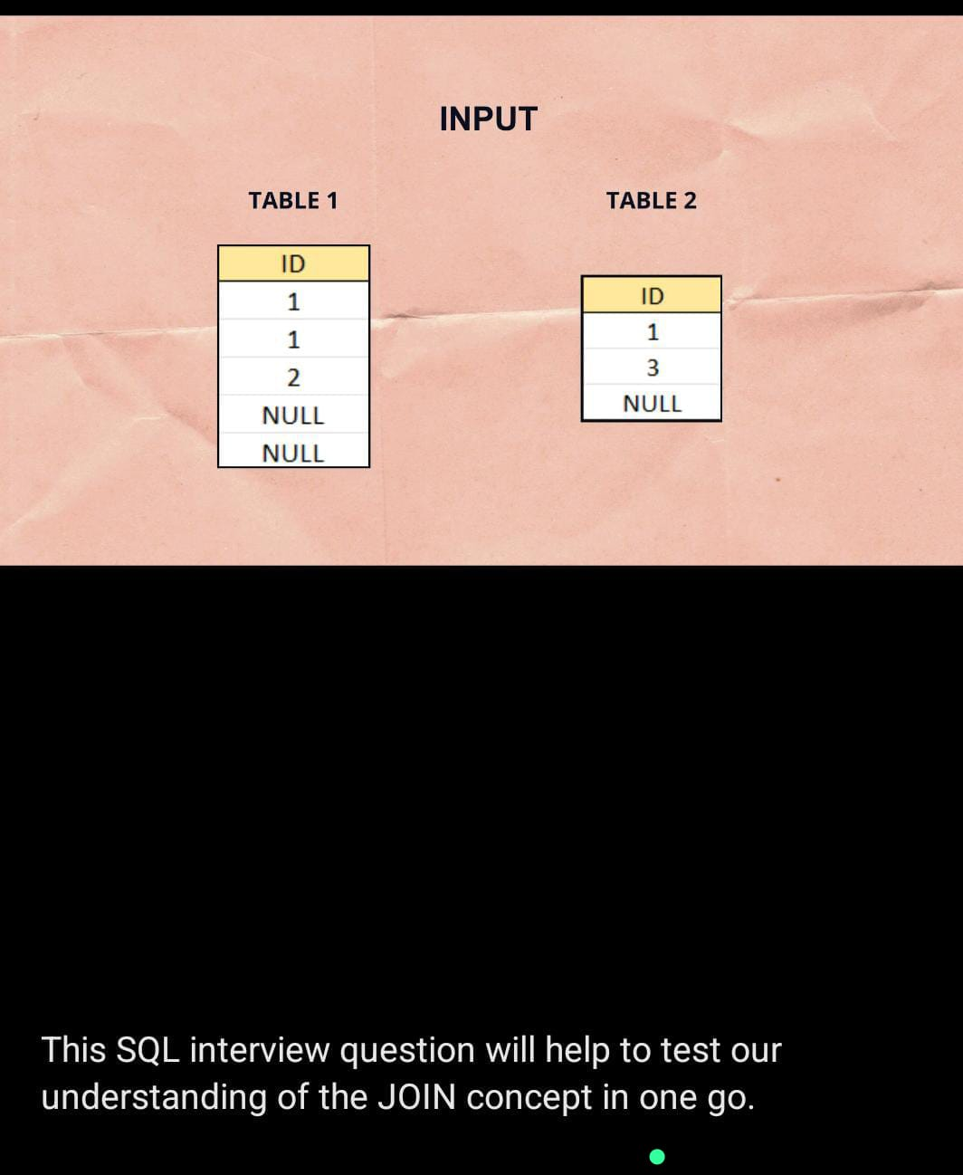

create table tbl1

(

id int

);

insert into tbl1 values(1),(1),(2),(NULL),(NULL);

select * from tbl1

create table tbl2

(

id int

);

insert into tbl2 values(1),(3),(NULL);

select * from tbl2

select * from tbl1 inner join tbl2 on tbl1.id=tbl2.id

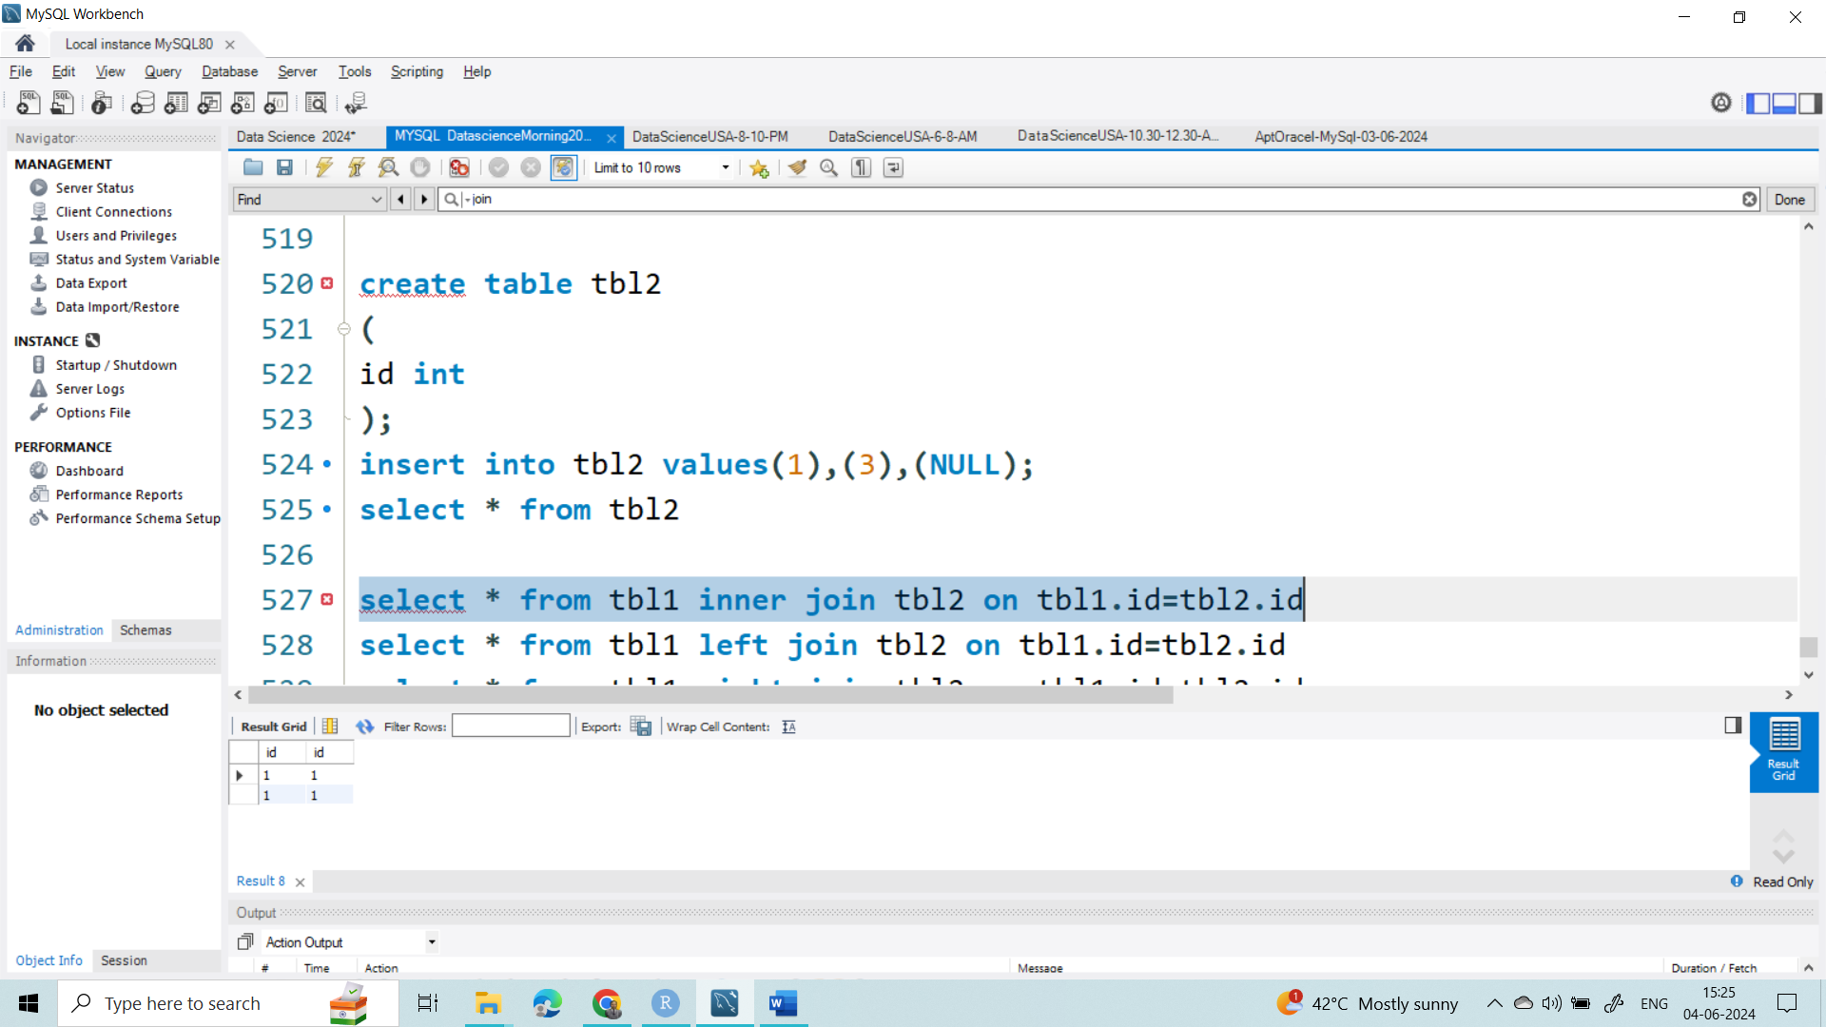

select * from tbl1 left join tbl2 on tbl1.id=tbl2.id

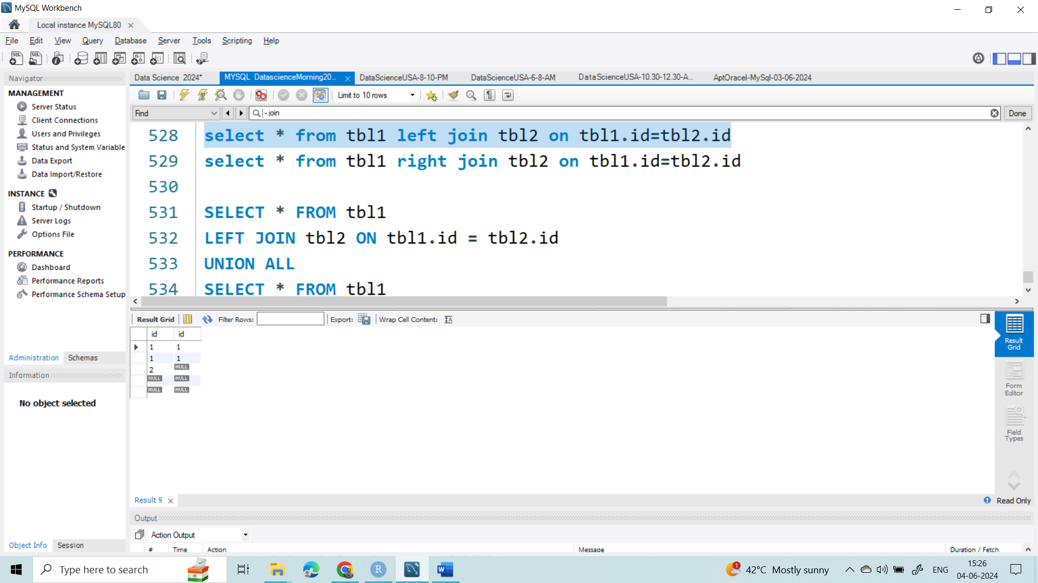

select * from tbl1 right join tbl2 on tbl1.id=tbl2.id

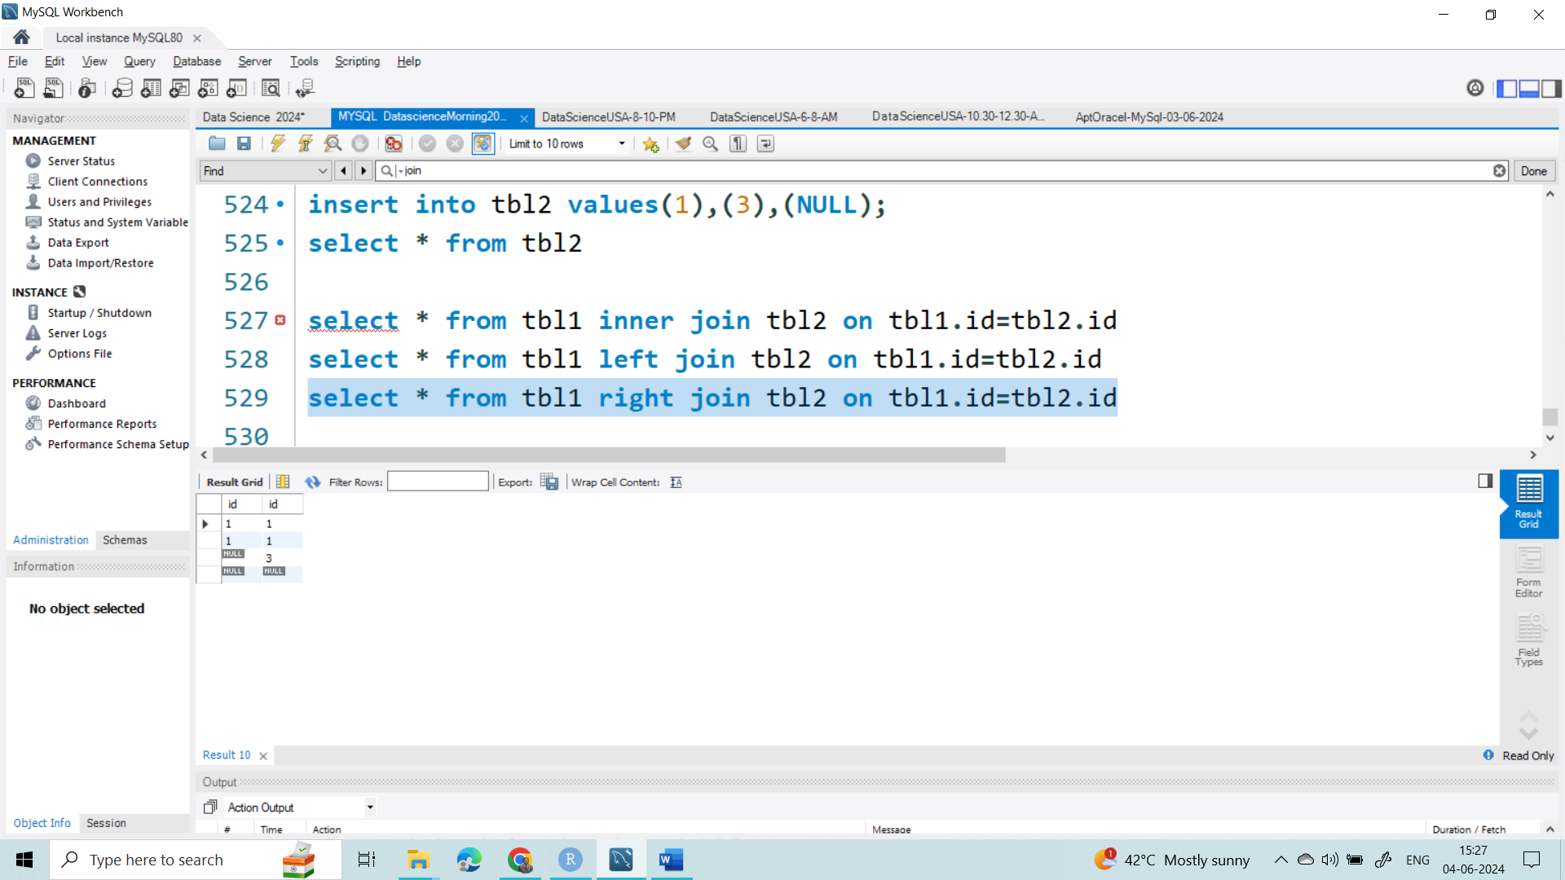

**--------Full Outer join is not supported in MySQL but we can use the combination of them-------**

SELECT * FROM tbl1

LEFT JOIN tbl2 ON tbl1.id = tbl2.id

UNION ALL

SELECT * FROM tbl1

RIGHT JOIN tbl2 ON tbl1.id = tbl2.id

WHERE tbl1.id IS NULL

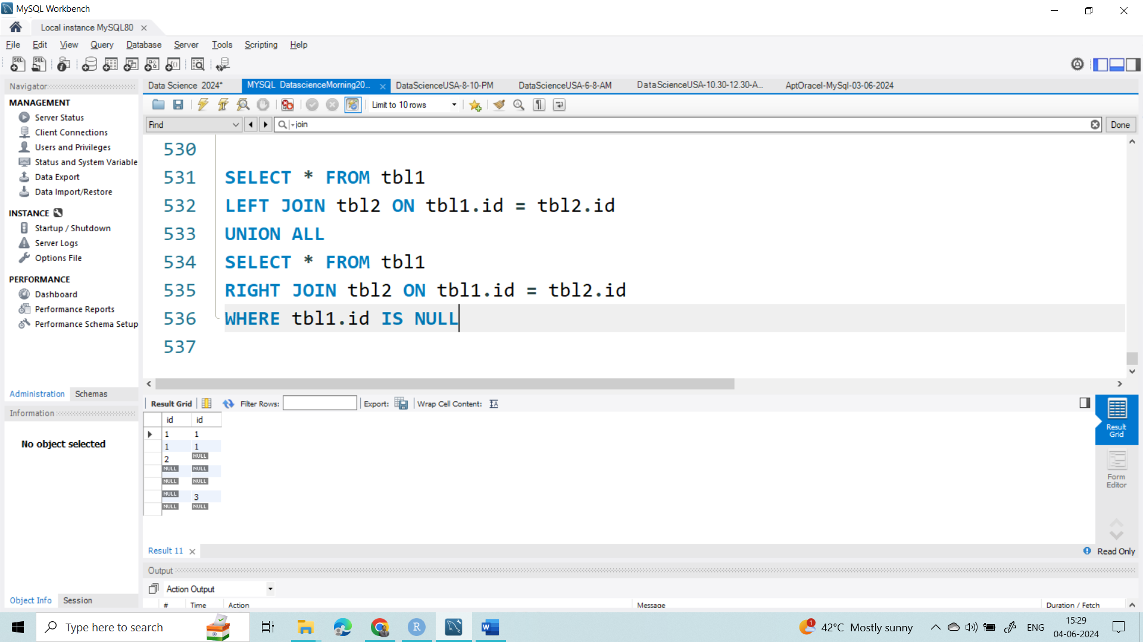

**Question-2**

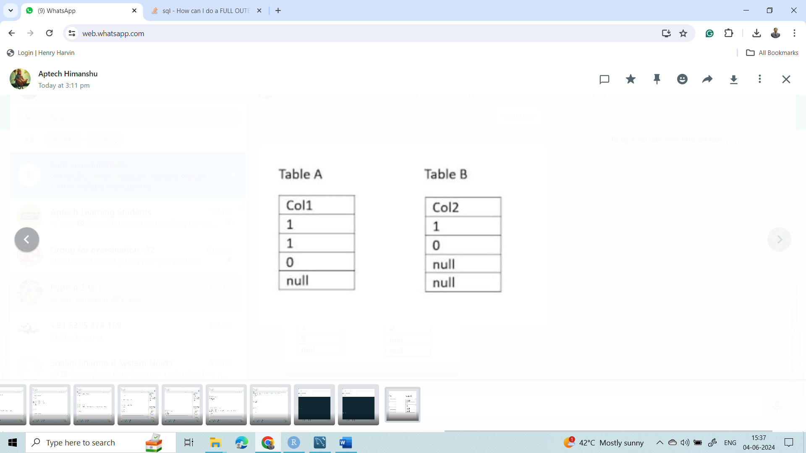

create table t1

(

id int

);

insert into t1 values(1),(1),(0),(NULL);

select * from t1

create table t2

(

id int

);

insert into t2 values(1),(0),(NULL),(NULL);

select * from t2

select * from t1 inner join t2 on t1.id=t2.id

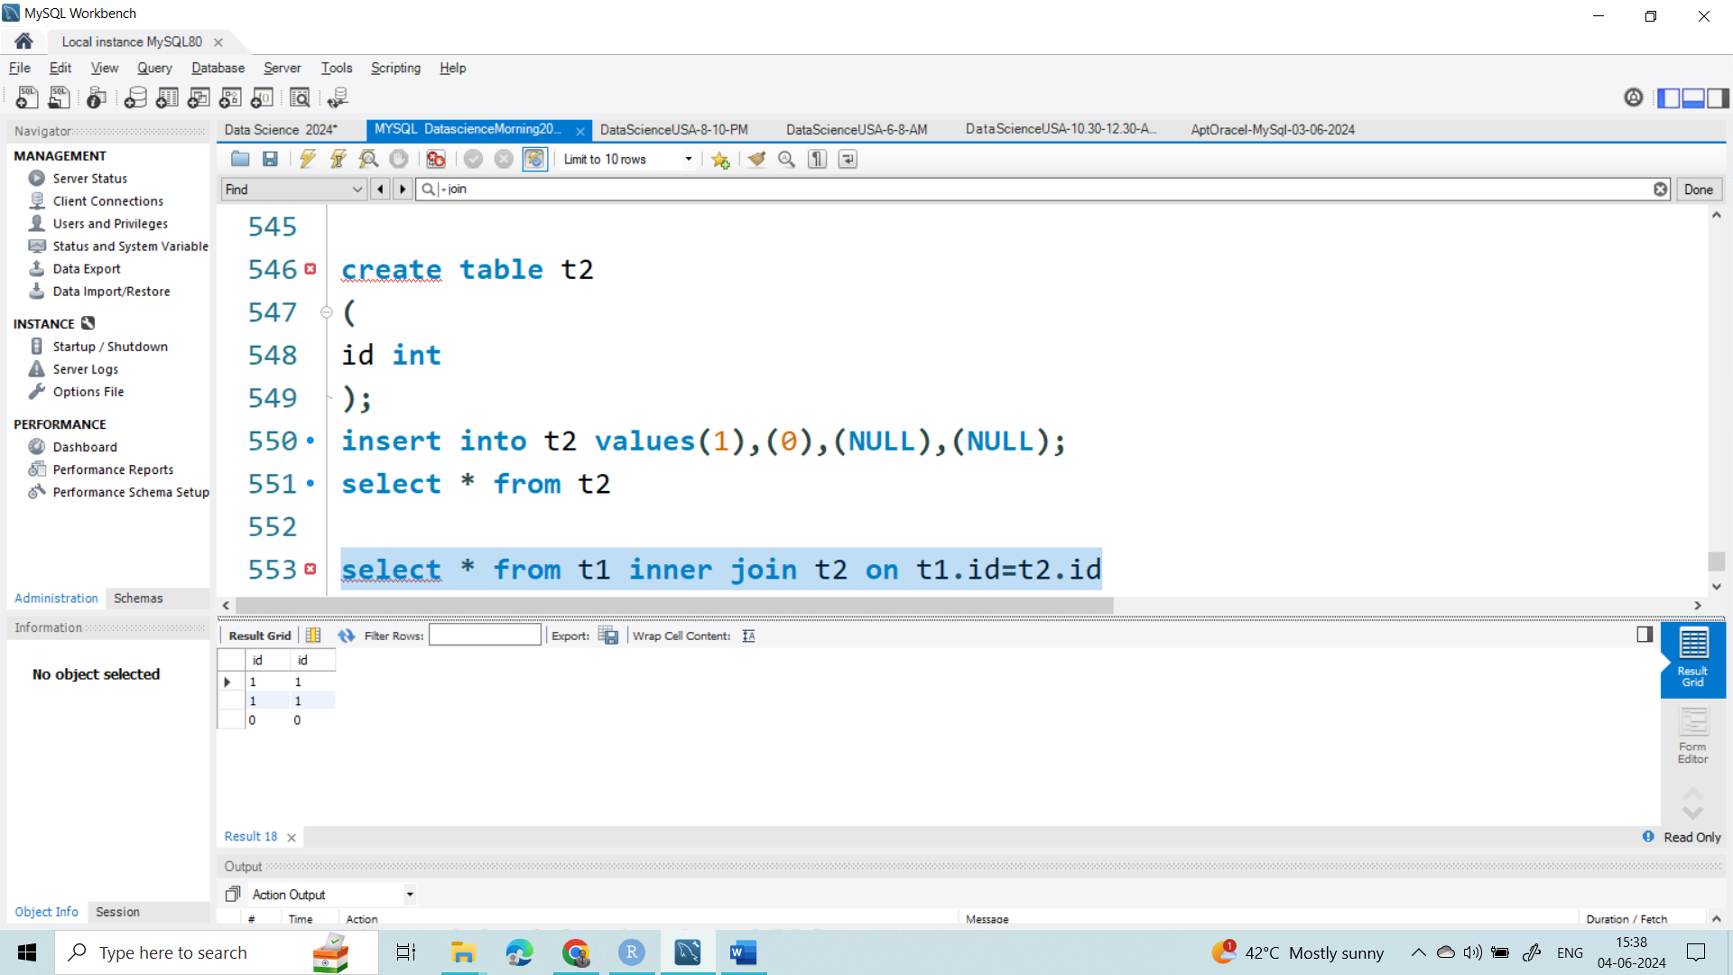

select * from t1 left join t2 on t1.id=t2.id

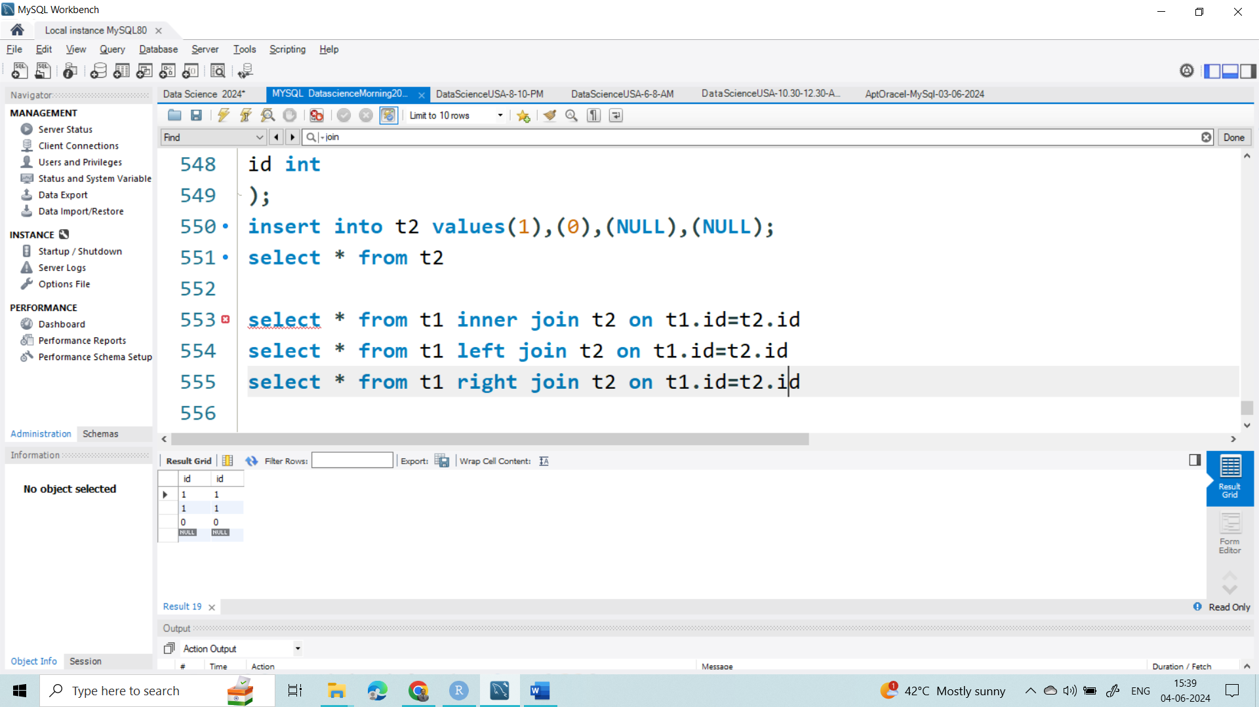

select * from t1 right join t2 on t1.id=t2.id

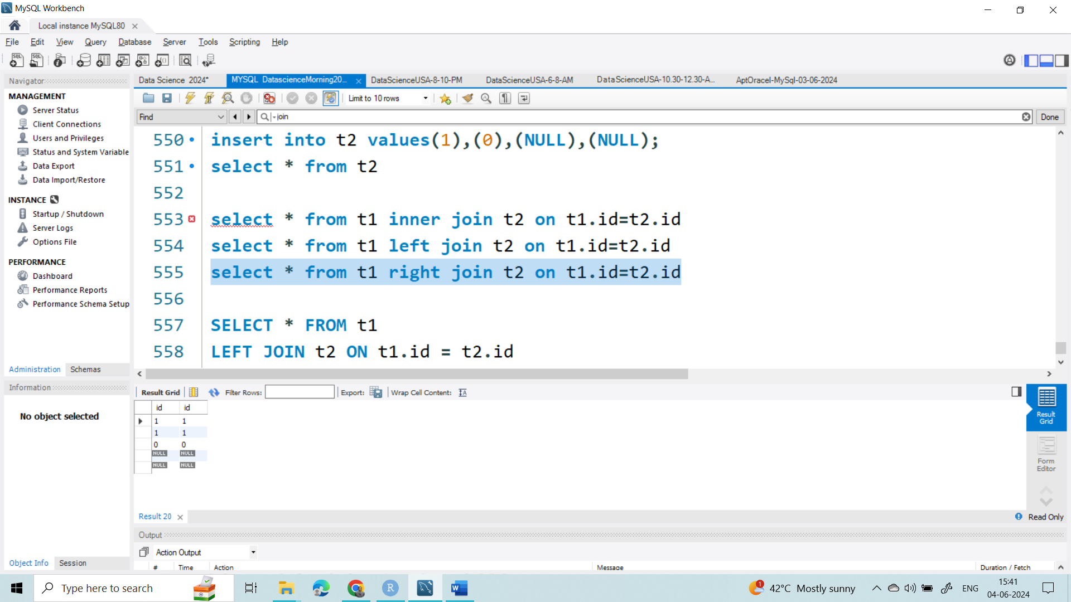

SELECT * FROM t1

LEFT JOIN t2 ON t1.id = t2.id

UNION ALL

SELECT * FROM t1

RIGHT JOIN t2 ON t1.id = t2.id

WHERE t1.id IS NULL

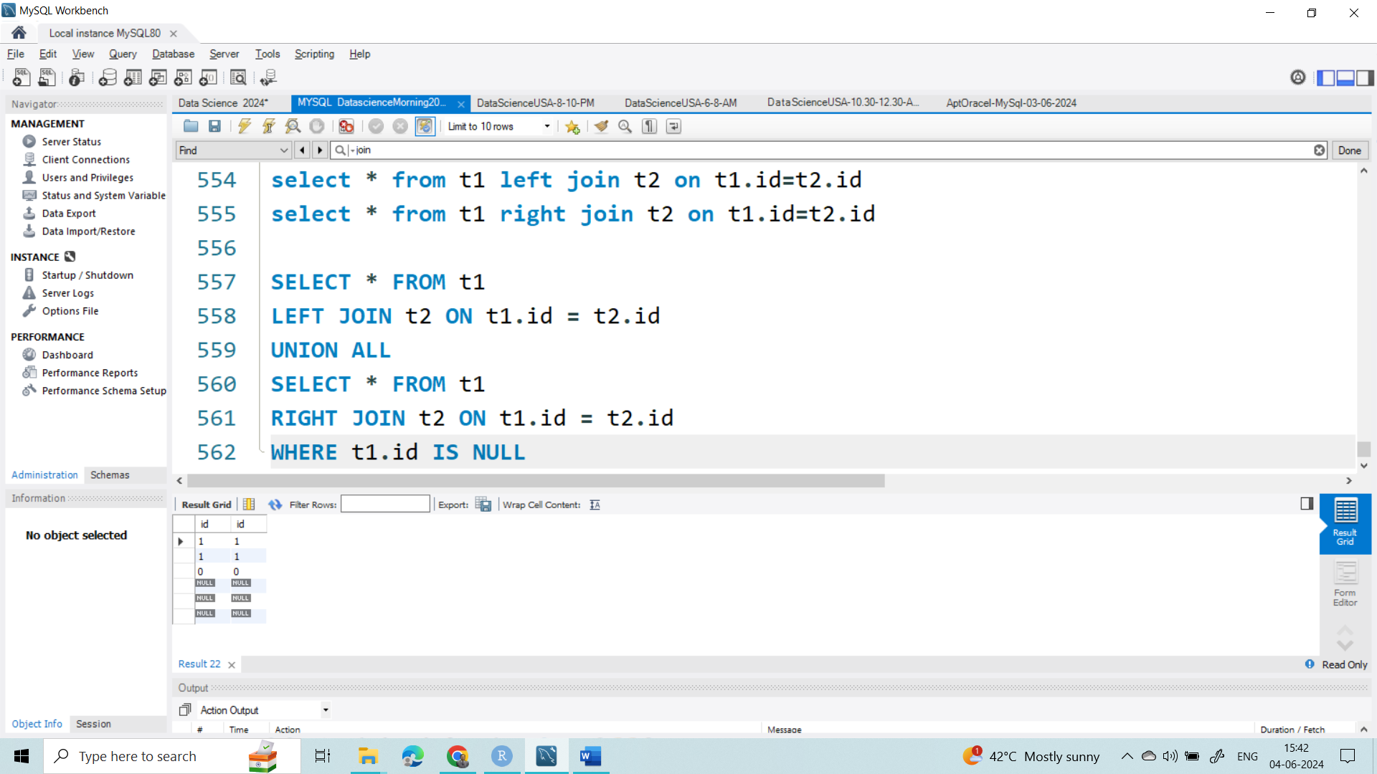

**Question-3**

|  |  |
| --- | --- |
| ID | ID |
| 1 | **1** |
| 1 | **0** |
| 1 | **1** |
| 1 | **0** |

create table tt1

(

id int

);

insert into tt1 values(1),(1),(1),(1);

select * from tt1

create table tt2

(

id int

);

insert into tt2 values(1),(0),(1),(0);

select * from tt2

select * from tt1 inner join tt2 on tt1.id=tt2.id

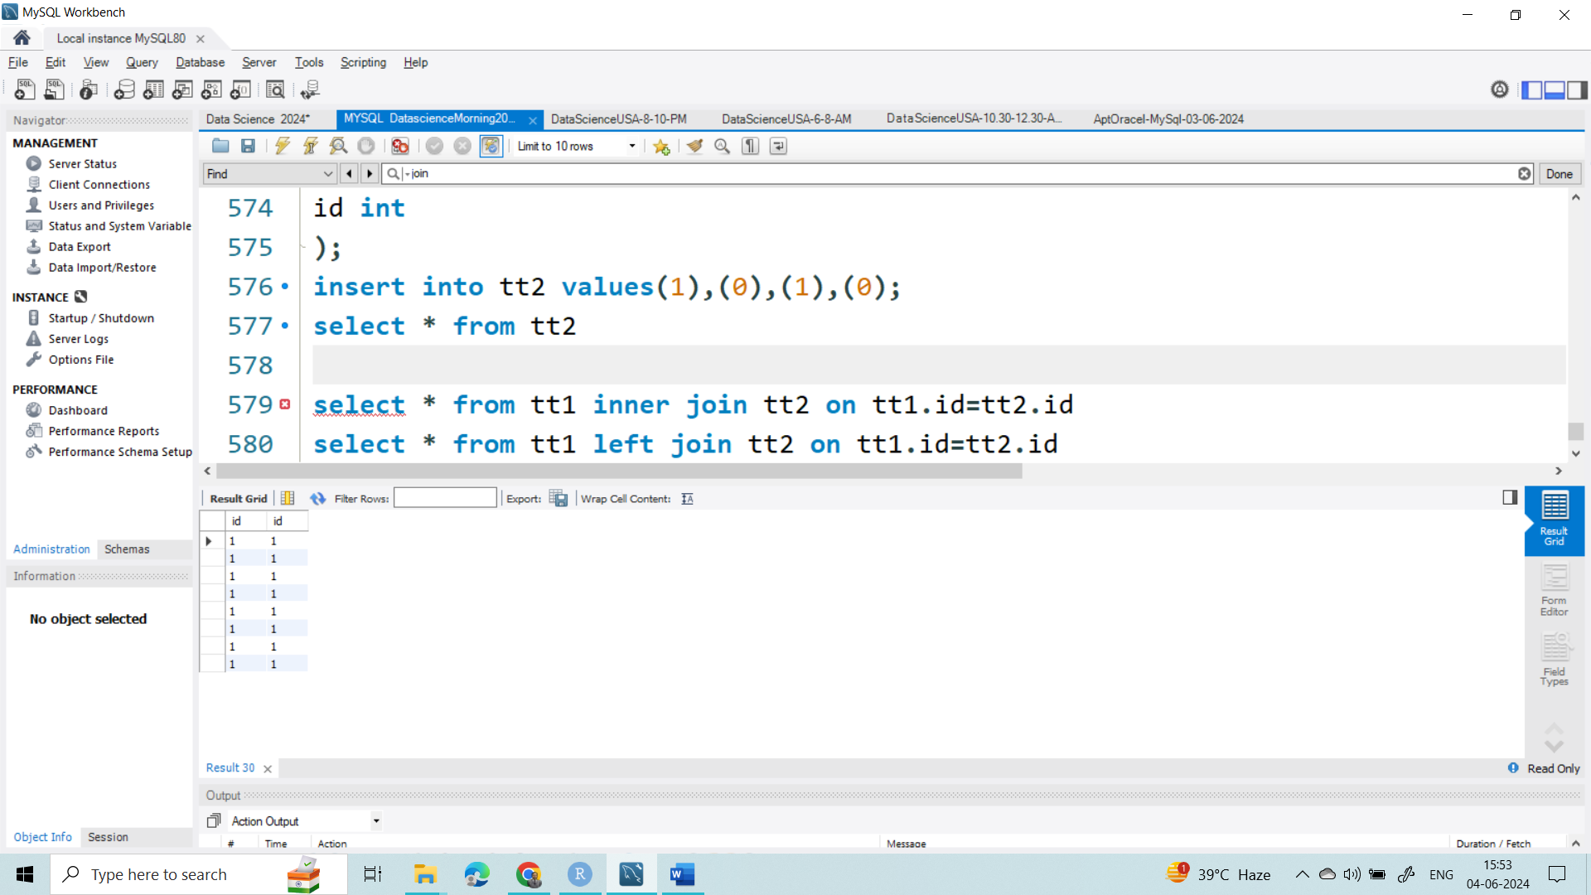

select * from tt1 left join tt2 on tt1.id=tt2.id

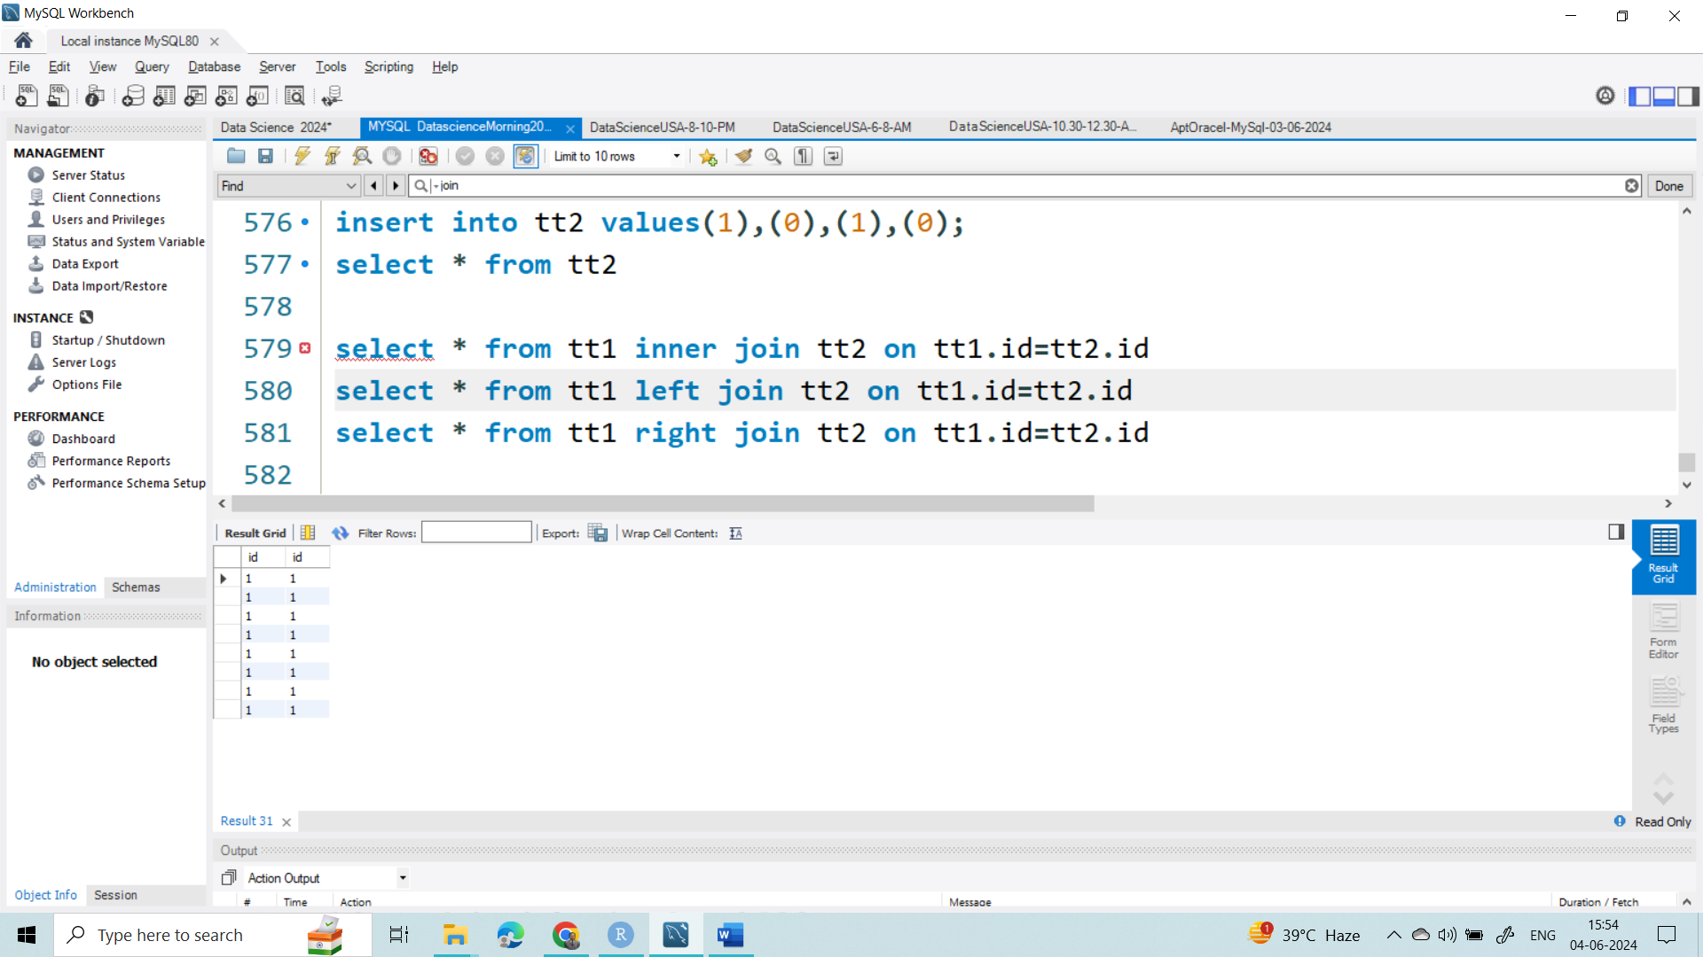

select * from tt1 right join tt2 on tt1.id=tt2.id

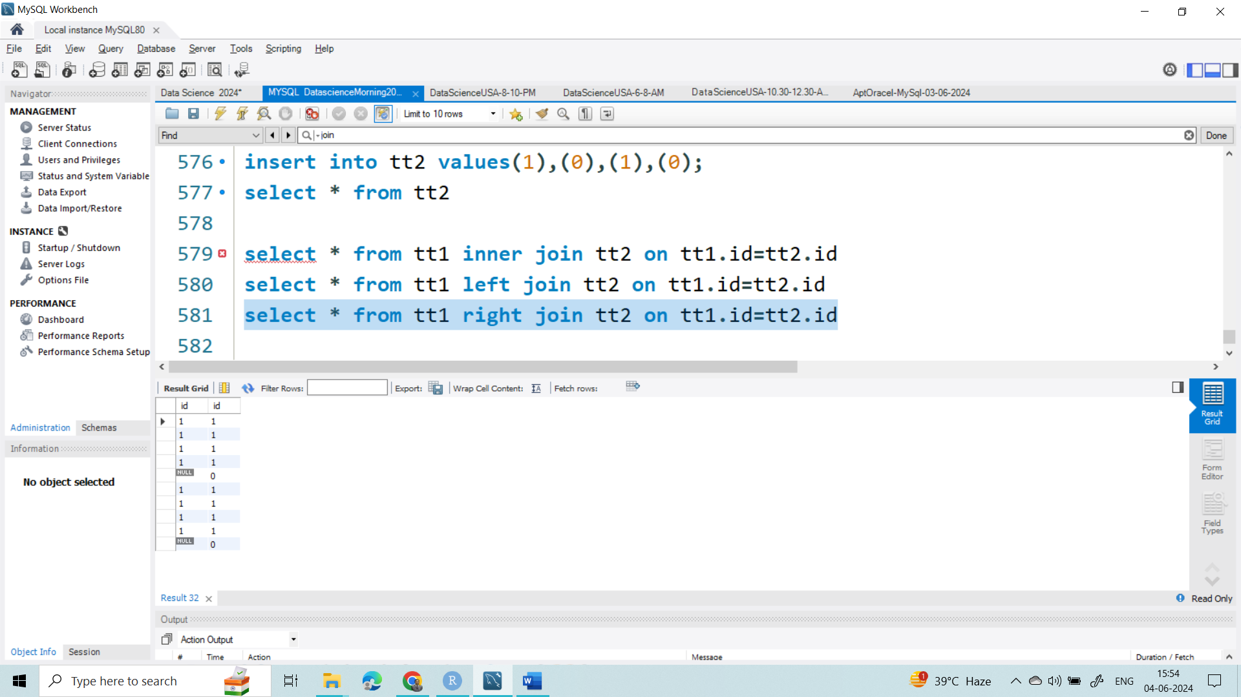

SELECT * FROM tt1

LEFT JOIN tt2 ON tt1.id = tt2.id

UNION ALL

SELECT * FROM tt1

RIGHT JOIN tt2 ON tt1.id = tt2.id

WHERE tt1.id IS NULL

